**Chapter 12_ Exception Handling and Recovery**

Chapter 12: Exception Handling and Recovery

For AI agents to operate reliably in diverse real-world environments, they must be able to manage unforeseen situations, errors, and malfunctions. Just as humans adapt to unexpected obstacles, intelligent agents need robust systems to detect problems, initiate recovery procedures, or at least ensure controlled failure. This essential requirement forms the basis of the Exception Handling and Recovery pattern.

This pattern focuses on developing exceptionally durable and resilient agents that can maintain uninterrupted functionality and operational integrity despite various difficulties and anomalies. It emphasizes the importance of both proactive preparation and reactive strategies to ensure continuous operation, even when facing challenges. This adaptability is critical for agents to function successfully in complex and unpredictable settings, ultimately boosting their overall effectiveness and trustworthiness.

The capacity to handle unexpected events ensures these AI systems are not only intelligent but also stable and reliable, which fosters greater confidence in their deployment and performance. Integrating comprehensive monitoring and diagnostic tools further strengthens an agent's ability to quickly identify and address issues, preventing potential disruptions and ensuring smoother operation in evolving conditions. These advanced systems are crucial for maintaining the integrity and efficiency of AI operations, reinforcing their ability to manage complexity and unpredictability.

This pattern may sometimes be used with reflection. For example, if an initial attempt fails and raises an exception, a reflective process can analyze the failure and reattempt the task with a refined approach, such as an improved prompt, to resolve the error.

**Exception Handling and Recovery Pattern Overview**

The Exception Handling and Recovery pattern addresses the need for AI agents to manage operational failures. This pattern involves anticipating potential issues, such as tool errors or service unavailability, and developing strategies to mitigate them. These strategies may include error logging, retries, fallbacks, graceful degradation, and notifications. Additionally, the pattern emphasizes recovery mechanisms like state rollback, diagnosis, self-correction, and escalation, to restore agents to stable operation. Implementing this pattern enhances the reliability and robustness of AI agents, allowing them to function in unpredictable environments. Examples of practical applications include chatbots managing database errors, trading bots handling financial errors, and smart home agents addressing device malfunctions. The pattern ensures that agents can continue to operate effectively despite encountering complexities and failures.

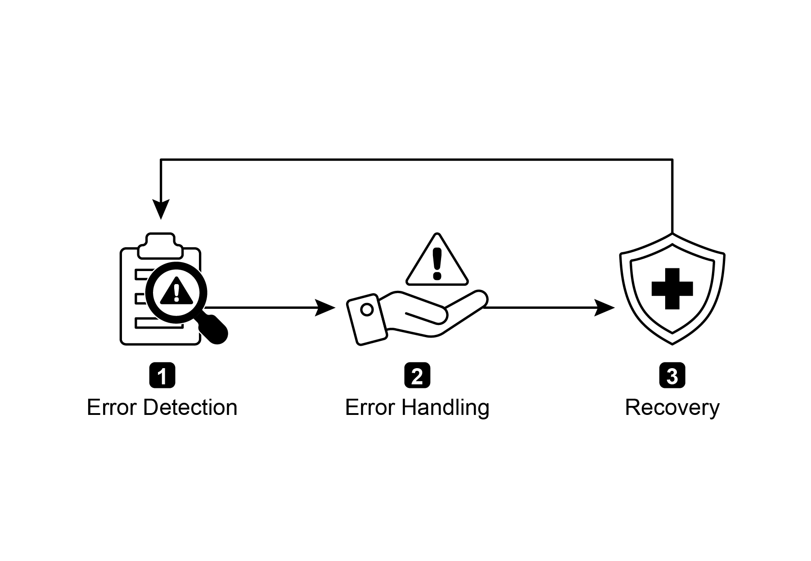

Fig.1: Key components of exception handling and recovery for AI agents

**Error Detection:** This involves meticulously identifying operational issues as they arise. This could manifest as invalid or malformed tool outputs, specific API errors such as 404 (Not Found) or 500 (Internal Server Error) codes, unusually long response times from services or APIs, or incoherent and nonsensical responses that deviate from expected formats. Additionally, monitoring by other agents or specialized monitoring systems might be implemented for more proactive anomaly detection, enabling the system to catch potential issues before they escalate.

**Error Handling**: Once an error is detected, a carefully thought-out response plan is essential. This includes recording error details meticulously in logs for later debugging and analysis (logging). Retrying the action or request, sometimes with slightly adjusted parameters, may be a viable strategy, especially for transient errors (retries). Utilizing alternative strategies or methods (fallbacks) can ensure that some functionality is maintained. Where complete recovery is not immediately possible, the agent can maintain partial functionality to provide at least some value (graceful degradation). Finally, alerting human operators or other agents might be crucial for situations that require human intervention or collaboration (notification).

**Recovery:** This stage is about restoring the agent or system to a stable and operational state after an error. It could involve reversing recent changes or transactions to undo the effects of the error (state rollback). A thorough investigation into the cause of the error is vital for preventing recurrence. Adjusting the agent's plan, logic, or parameters through a self-correction mechanism or replanning process may be needed to avoid the same error in the future. In complex or severe cases, delegating the issue to a human operator or a higher-level system (escalation) might be the best course of action.

Implementation of this robust exception handling and recovery pattern can transform AI agents from fragile and unreliable systems into robust, dependable components capable of operating effectively and resiliently in challenging and highly unpredictable environments. This ensures that the agents maintain functionality, minimize downtime, and provide a seamless and reliable experience even when faced with unexpected issues.

**Practical Applications & Use Cases**

Exception Handling and Recovery is critical for any agent deployed in a real-world scenario where perfect conditions cannot be guaranteed.

* **Customer Service Chatbots:** If a chatbot tries to access a customer database and the database is temporarily down, it shouldn't crash. Instead, it should detect the API error, inform the user about the temporary issue, perhaps suggest trying again later, or escalate the query to a human agent.
* **Automated Financial Trading:** A trading bot attempting to execute a trade might encounter an "insufficient funds" error or a "market closed" error. It needs to handle these exceptions by logging the error, not repeatedly trying the same invalid trade, and potentially notifying the user or adjusting its strategy.
* **Smart Home Automation:** An agent controlling smart lights might fail to turn on a light due to a network issue or a device malfunction. It should detect this failure, perhaps retry, and if still unsuccessful, notify the user that the light could not be turned on and suggest manual intervention.
* **Data Processing Agents:** An agent tasked with processing a batch of documents might encounter a corrupted file. It should skip the corrupted file, log the error, continue processing other files, and report the skipped files at the end rather than halting the entire process.
* **Web Scraping Agents:** When a web scraping agent encounters a CAPTCHA, a changed website structure, or a server error (e.g., 404 Not Found, 503 Service Unavailable), it needs to handle these gracefully. This could involve pausing, using a proxy, or reporting the specific URL that failed.
* **Robotics and Manufacturing:** A robotic arm performing an assembly task might fail to pick up a component due to misalignment. It needs to detect this failure (e.g., via sensor feedback), attempt to readjust, retry the pickup, and if persistent, alert a human operator or switch to a different component.

In short, this pattern is fundamental for building agents that are not only intelligent but also reliable, resilient, and user-friendly in the face of real-world complexities.

**Hands-On Code Example (ADK)**

Exception handling and recovery are vital for system robustness and reliability. Consider, for instance, an agent's response to a failed tool call. Such failures can stem from incorrect tool input or issues with an external service that the tool depends on.

|  |
| --- |
| from google.adk.agents import Agent, SequentialAgent  # Agent 1: Tries the primary tool. Its focus is narrow and clear.  primary_handler = Agent(  name="primary_handler",  model="gemini-2.0-flash-exp",  instruction="""  Your job is to get precise location information.  Use the get_precise_location_info tool with the user's provided address.  """,  tools=[get_precise_location_info]  )  # Agent 2: Acts as the fallback handler, checking state to decide its action.  fallback_handler = Agent(  name="fallback_handler",  model="gemini-2.0-flash-exp",  instruction="""  Check if the primary location lookup failed by looking at state["primary_location_failed"].  - If it is True, extract the city from the user's original query and use the get_general_area_info tool.  - If it is False, do nothing.  """,  tools=[get_general_area_info]  )  # Agent 3: Presents the final result from the state.  response_agent = Agent(  name="response_agent",  model="gemini-2.0-flash-exp",  instruction="""  Review the location information stored in state["location_result"].  Present this information clearly and concisely to the user.  If state["location_result"] does not exist or is empty, apologize that you could not retrieve the location.  """,  tools=[] # This agent only reasons over the final state.  )  # The SequentialAgent ensures the handlers run in a guaranteed order.  robust_location_agent = SequentialAgent(  name="robust_location_agent",  sub_agents=[primary_handler, fallback_handler, response_agent]  ) |

This code defines a robust location retrieval system using a ADK's SequentialAgent with three sub-agents. The primary_handler is the first agent, attempting to get precise location information using the get_precise_location_info tool. The fallback_handler acts as a backup, checking if the primary lookup failed by inspecting a state variable. If the primary lookup failed, the fallback agent extracts the city from the user's query and uses the get_general_area_info tool. The response_agent is the final agent in the sequence. It reviews the location information stored in the state. This agent is designed to present the final result to the user. If no location information was found, it apologizes. The SequentialAgent ensures that these three agents execute in a predefined order. This structure allows for a layered approach to location information retrieval.

**At a Glance**

**What:** AI agents operating in real-world environments inevitably encounter unforeseen situations, errors, and system malfunctions. These disruptions can range from tool failures and network issues to invalid data, threatening the agent's ability to complete its tasks. Without a structured way to manage these problems, agents can be fragile, unreliable, and prone to complete failure when faced with unexpected hurdles. This unreliability makes it difficult to deploy them in critical or complex applications where consistent performance is essential.

**Why**: The Exception Handling and Recovery pattern provides a standardized solution for building robust and resilient AI agents. It equips them with the agentic capability to anticipate, manage, and recover from operational failures. The pattern involves proactive error detection, such as monitoring tool outputs and API responses, and reactive handling strategies like logging for diagnostics, retrying transient failures, or using fallback mechanisms. For more severe issues, it defines recovery protocols, including reverting to a stable state, self-correction by adjusting its plan, or escalating the problem to a human operator. This systematic approach ensures agents can maintain operational integrity, learn from failures, and function dependably in unpredictable settings.

**Rule of thumb:** Use this pattern for any AI agent deployed in a dynamic, real-world environment where system failures, tool errors, network issues, or unpredictable inputs are possible and operational reliability is a key requirement.

**Visual summary**

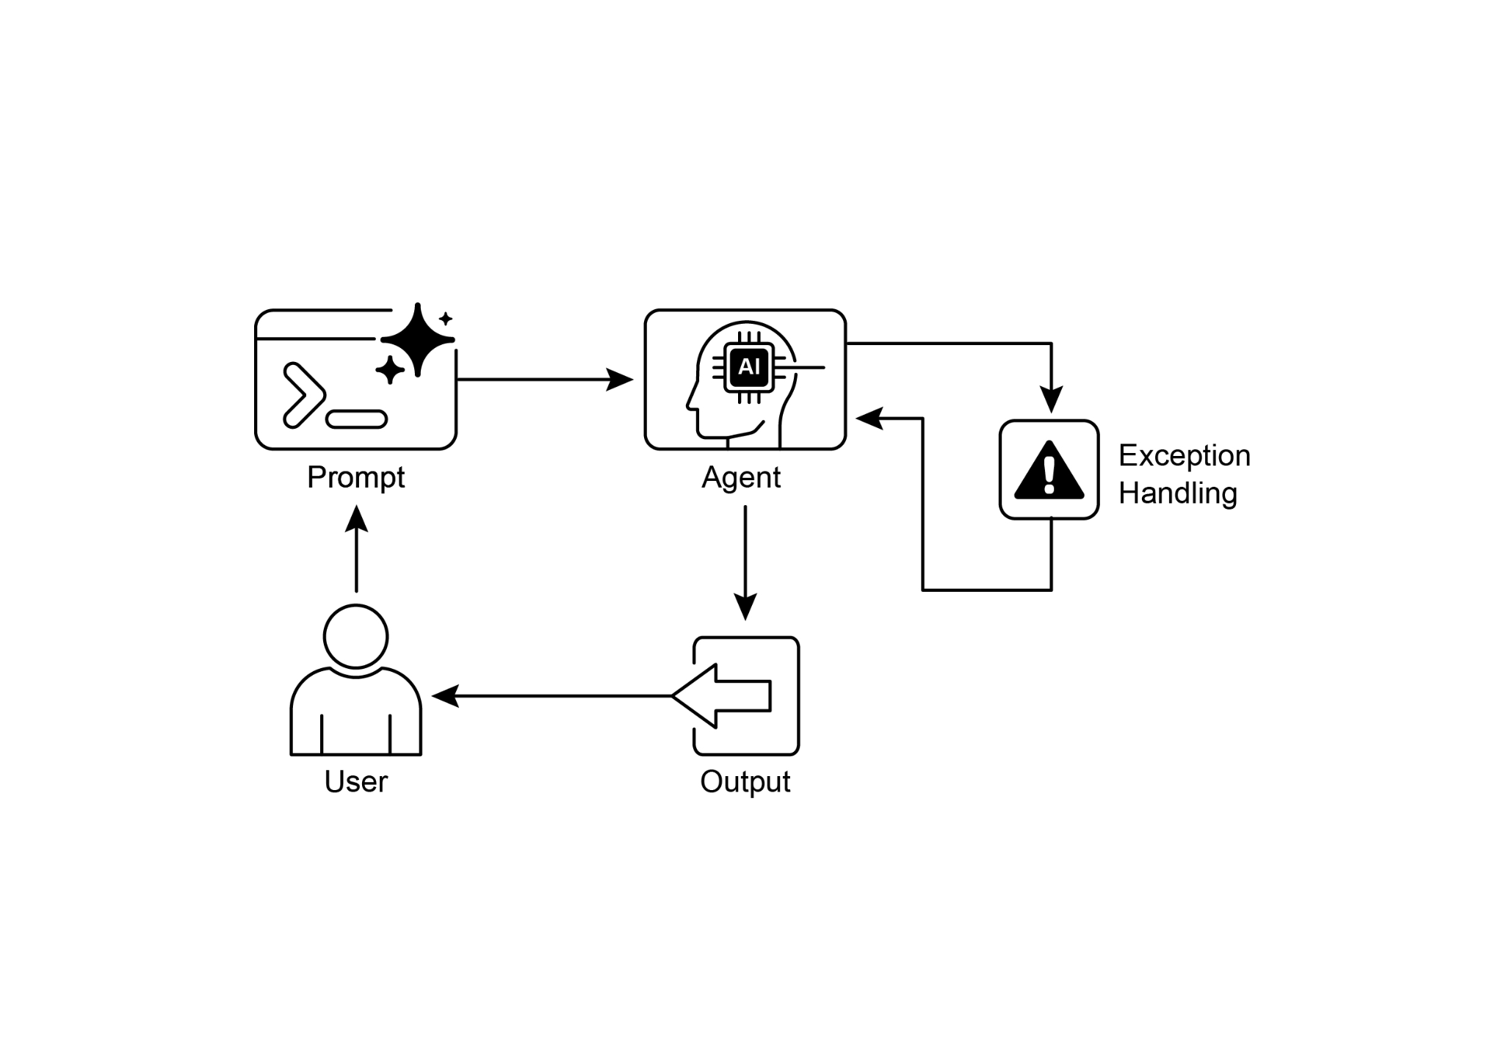

Fig.2: Exception handling pattern

**Key Takeaways**

Essential points to remember:

* Exception Handling and Recovery is essential for building robust and reliable Agents.
* This pattern involves detecting errors, handling them gracefully, and implementing strategies to recover.
* Error detection can involve validating tool outputs, checking API error codes, and using timeouts.
* Handling strategies include logging, retries, fallbacks, graceful degradation, and notifications.
* Recovery focuses on restoring stable operation through diagnosis, self-correction, or escalation.
* This pattern ensures agents can operate effectively even in unpredictable real-world environments.

**Conclusion**

This chapter explores the Exception Handling and Recovery pattern, which is essential for developing robust and dependable AI agents. This pattern addresses how AI agents can identify and manage unexpected issues, implement appropriate responses, and recover to a stable operational state. The chapter discusses various aspects of this pattern, including the detection of errors, the handling of these errors through mechanisms such as logging, retries, and fallbacks, and the strategies used to restore the agent or system to proper function. Practical applications of the Exception Handling and Recovery pattern are illustrated across several domains to demonstrate its relevance in handling real-world complexities and potential failures. These applications show how equipping AI agents with exception handling capabilities contributes to their reliability and adaptability in dynamic environments.

**References**

1. McConnell, S. (2004). *Code Complete (2nd ed.)*. Microsoft Press.
2. Shi, Y., Pei, H., Feng, L., Zhang, Y., & Yao, D. (2024). *Towards Fault Tolerance in Multi-Agent Reinforcement Learning*. arXiv preprint arXiv:2412.00534.
3. O'Neill, V. (2022). *Improving Fault Tolerance and Reliability of Heterogeneous Multi-Agent IoT Systems Using Intelligence Transfer*. Electronics, 11(17), 2724.

**第12章_异常处理与恢复**

第12章：异常处理与恢复

为了使AI智能体能够在各种现实世界环境中可靠运行，它们必须能够应对不可预见的情况、错误和故障。就像人类适应意外障碍一样，智能体需要强大的系统来检测问题、启动恢复程序，或至少确保故障可控。这一基本要求构成了异常处理和恢复模式的基础。

这种模式着重于开发极其耐用和有韧性的智能体，使其能够在各种困难和异常情况下保持不间断的功能和操作完整性。它强调主动准备和被动策略的重要性，以确保即使面临挑战也能持续运行。这种适应性对于智能体在复杂和不可预测的环境中成功运行至关重要，最终将提高其整体有效性和可信度。

处理突发事件的能力确保了这些AI系统不仅智能，而且稳定可靠，这增强了人们对其部署和性能的信心。集成全面的监控和诊断工具进一步强化了智能体快速识别和解决问题的能力，防止潜在的中断，并确保在不断变化的条件下更顺畅地运行。这些先进的系统对于维护AI操作的完整性和效率至关重要，增强了它们管理复杂性和不可预测性的能力。

这种模式有时可以与反思结合使用。例如，如果初始尝试失败并引发异常，反思过程可以分析失败原因，并采用改进的方法（如优化提示）重新尝试任务，以解决错误。

**异常处理与恢复模式概述**

异常处理与恢复模式旨在满足AI智能体管理操作故障的需求。该模式包括预测潜在问题，如工具错误或服务不可用，并制定减轻这些问题的策略。这些策略可能包括错误日志记录、重试、回退、优雅降级和通知。此外，该模式强调恢复机制，如状态回滚、诊断、自我纠正和升级，以使智能体恢复到稳定运行状态。实施此模式可增强AI智能体的可靠性和健壮性，使其能够在不可预测的环境中运行。实际应用示例包括管理数据库错误的聊天机器人、处理财务错误的交易机器人以及解决设备故障的智能家居智能体。该模式确保智能体即使遇到复杂性和故障也能继续有效运行。

图1：AI智能体异常处理与恢复的关键组件

**错误检测：**这包括在操作问题出现时对其进行细致的识别。这些问题可能表现为无效或格式错误的工具输出、特定的 API 错误（如 404（未找到）或 500（内部服务器错误）代码）、服务或 API 的响应时间异常长，或者偏离预期格式的不连贯、无意义的响应。此外，还可以通过其他代理或专门的监控系统进行监控，以便更主动地检测异常，使系统能够在潜在问题升级之前将其捕获。

**错误处理**：一旦检测到错误，精心设计的响应计划就至关重要。这包括在日志中详细记录错误细节，以便日后调试和分析（日志记录）。重试操作或请求，有时稍微调整参数，可能是一种可行的策略，特别是对于临时性错误（重试）。采用替代策略或方法（回退）可以确保某些功能得以维持。在无法立即完全恢复的情况下，代理可以维持部分功能，以至少提供一些价值（优雅降级）。最后，在需要人工干预或协作的情况下，向人工操作员或其他代理发出警报可能至关重要（通知）。

**恢复阶段：**此阶段旨在使代理或系统在出现错误后恢复到稳定且可运行的状态。这可能涉及撤销最近的更改或事务，以消除错误的影响（状态回滚）。对错误原因进行全面调查对于防止错误再次发生至关重要。可能需要通过自我纠正机制或重新规划过程来调整代理的计划、逻辑或参数，以避免未来出现同样的错误。在复杂或严重的情况下，将问题委派给人工操作员或更高级别的系统（升级）可能是最佳行动方案。

实施这种强大的异常处理和恢复模式，可以将AI智能体从脆弱、不可靠的系统转变为能够在充满挑战且高度不可预测的环境中有效、稳健运行的强大、可靠组件。这确保了智能体即使在面临意外问题时也能保持功能、最大限度减少停机时间，并提供无缝、可靠的体验。

**实际应用与用例**

异常处理和恢复对于部署在无法保证完美条件的现实场景中的任何主体来说都是至关重要的。

* **客户服务聊天机器人：**如天机器人试图访问客户数据库，而该数据库暂时无法使用，它不应崩溃。相反，它应该检测到 API 错误，告知用户这一临时问题，或许建议稍后再试，或将查询升级到人主体处理。
* **自动化金融交易：**尝试执行交易的交易机器人可能会遇到“资金不足”错误或“市场休市”错误。它需要通过记录错误、不再重复尝试相同的无效交易，并可能通知用户或调整其策略来处理这些异常。
* **智能家居自动化：**控制智能灯的代理可能由于网络问题或设备故障而无法打开灯。它应该检测到这种故障，可能会重试，如果仍然失败，则通知用户灯无法打开，并建议手动干预。
* **数据处理代理：**负责处理一批文档的代理可能会遇到损坏的文件。它应该跳过损坏的文件，记录错误，继续处理其他文件，并在最后报告被跳过的文件，而不是停止整个处理过程。
* **网页抓取代理：**当网页抓取代理遇到验证码、网站结构变更或服务器错误（例如404未找到、503服务不可用）时，需要妥善处理这些情况。这可能包括暂停、使用代理或报告失败的特定URL。
* **机器人技术与制造业：**执行装配任务的机械臂可能因未对准而无法抓取部件。它需要检测到这种故障（例如，通过传感器反馈），尝试重新调整，重试抓取，如果问题仍然存在，则提醒人工操作员或切换到不同的部件。

简而言之，这种模式对于构建不仅智能，而且在面对现实世界的复杂性时可靠、有韧性且用户友好的智能体至关重要。

**实践代码示例（ADK）**

异常处理和恢复对于系统的健壮性和可靠性至关重要。例如，考虑代理对工具调用失败的响应。此类失败可能源于工具输入错误或工具所依赖的外部服务出现问题。

|  |
| --- |
| from google.adk.agents import Agent, SequentialAgent  # 代理1：尝试使用主要工具。其重点明确且范围较窄。  primary_handler = Agent(  name="primary_handler",  model="gemini-2.0-flash-exp",  instruction="""  你的工作是获确的位置信息。  使用get_precise_location_info工具，结合用户提供的地址。  """,  tools=[获确位置信息]  )  # 代理2：充当备用处理程序，检查状态以决定其操作。  fallback_handler = Agent(  name="fallback_handler",  model="gemini-2.0-flash-exp",  instruction="""  通过查看state["primary_location_failed"]来检查主要位置查找是否失败。  -如果为True，则从用户的原始查询中提取城市信息，并使用get_general_area_info工具。  -如果为False，则不执行任何操作。  """,  tools=[get_general_area_info]  )  # 代理3：展示状态中的最终结果。  response_agent = Agent(  name="response_agent",  model="gemini-2.0-flash-exp",  instruction="""  查看存储在state["location_result"]中的位置信息。  向用户清晰、简洁地呈现此信息。  如果state["location_result"]不存在或为空，请为无法获取位置信息而致歉。  """,  tools=[] # 此智能体仅对最终状态进行推理。  )  # SequentialAgent确保处理程序按保证的顺序运行。  robust_location_agent = SequentialAgent(  name="robust_location_agent",  sub_agents=[primary_handler, fallback_handler, response_agent]  ) |

此代码使用ADK的SequentialAgent定义了一个强大的位置检索系统，该系统包含三个子代理。primary_handler是第一个代理，它尝试使用get_precise_location_info工具获确的位置信息。fallback_handler作为备用代理，通过检查状态变量来判断主查找是否失败。如果主查找失败，备用代理会从用户查询中提取城市信息，并使用get_general_area_info工具。response_agent是序列中的最后一个代理，它会查看存储在状态中的位置信息，旨在向用户呈现最终结果。如果未找到位置信息，它会表示歉意。SequentialAgent确保这三个代理按预定义的顺序执行，这种结构允许采用分层方法进行位置信息检索。

**概览**

**问题描述：**在现实世界环境中运行的AI智能体不可避免地会遇到不可预见的情况、错误和系统故障。这些干扰可能包括工具故障、网络问题到无效数据，威胁到智能体完成任务的能力。如果没有一种结构化的方法来管理这些问题，智能体可能会很脆弱、不可靠，并且在面对意外障碍时容易完全失败。这种不可靠性使得在需要持续稳定性能的关键或复杂应用中部署它们变得困难。

**原因**：异常处理与恢复模式为构建健壮且有弹性的AI智能体提供了标准化解决方案。它赋予智能体预见、管理和从操作故障中恢复的能力。该模式涉及主动错误检测，如监控工具输出和API响应，以及被动处理策略，如记录日志以进行诊断、重试临时故障或使用备用机制。对于更严重的问题，它定义了恢复协议，包括恢复到稳定状态、通过调整计划进行自我纠正，或将问题升级给人工操作员。这种系统化的方法确保智能体能够保持操作完整性，从故障中学习，并在不可预测的环境中可靠运行。

**经验法则：**对于部署在动态现实环境中的任何AI智能体，若该环境中可能出现系统故障、工具错误、网络问题或不可预测的输入，且运行可靠性是关键要求，则使用此模式。

**可视化总结**

图2：异常处理模式

**要点总结**

要点提示：

* 异常处理和恢复对于构建健壮且可靠的智能体至关重要。
* 这种模式包括检测错误、妥善处理错误，并实施恢复策略。
* 错误检测可能涉及验证工具输出、检查 API 错误代码以及使用超时机制。
* 处理策略包括日志记录、重试、回退、优雅降级和通知。
* 恢复工作重点在于通过诊断、自我纠正或升级来恢复稳定运行。
* 这种模式确保代理即使在不可预测的现实世界环境中也能有效运行。

**结论**

本章探讨异常处理与恢复模式，该模式对于开发健壮且可靠的AI智能体至关重要。此模式阐述了AI智能体如何识别和处理意外问题、实施适当的响应措施，以及恢复到稳定的运行状态。本章讨论了该模式的各个方面，包括错误检测、通过日志记录、重试和回退等机制处理这些错误，以及用于使智能体或系统恢复正常功能的策略。通过多个领域的实例展示了异常处理与恢复模式的实际应用，以证明其在应对现实世界的复杂性和潜在故障方面的相关性。这些应用表明，为AI智能体配备异常处理能力有助于提高其在动态环境中的可靠性和适应性。

**参考文献**

1. 麦康奈尔，S.（2004年）。*《代码大全》（第2版）*。微软出版社。
2. Shi, Y., Pei, H., Feng, L., Zhang, Y., & Yao, D. (2024). *迈向多智能体强化学习中的容错性*. arXiv预印本arXiv:2412.00534.
3. 奥尼尔，V.（2022年）。*利用智能转移提高异构多智能体物联网系统的容错性和可靠性*。《电子学》，11（17），2724。